Task 1:
Book Struct:
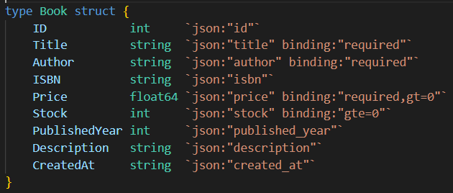
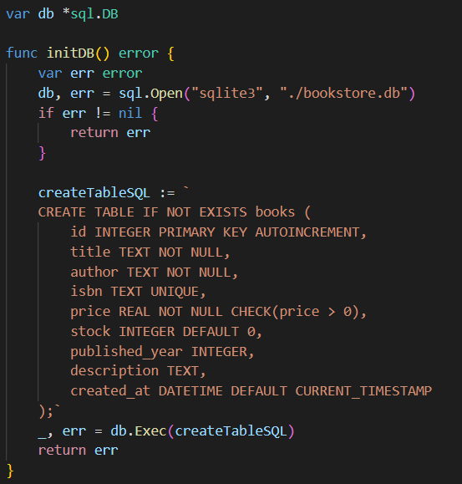
- Calls sql.Open("sqlite3", "./bookstore.db") to open the DB connection and assigns it to the package-level db variable.
- Builds a CREATE TABLE IF NOT EXISTS books (...) SQL string defining columns, constraints, and defaults.
- Executes the CREATE TABLE statement via db.Exec(createTableSQL) to create the table when absent.
- Returns any error encountered (either from opening the DB or executing the CREATE TABLE).

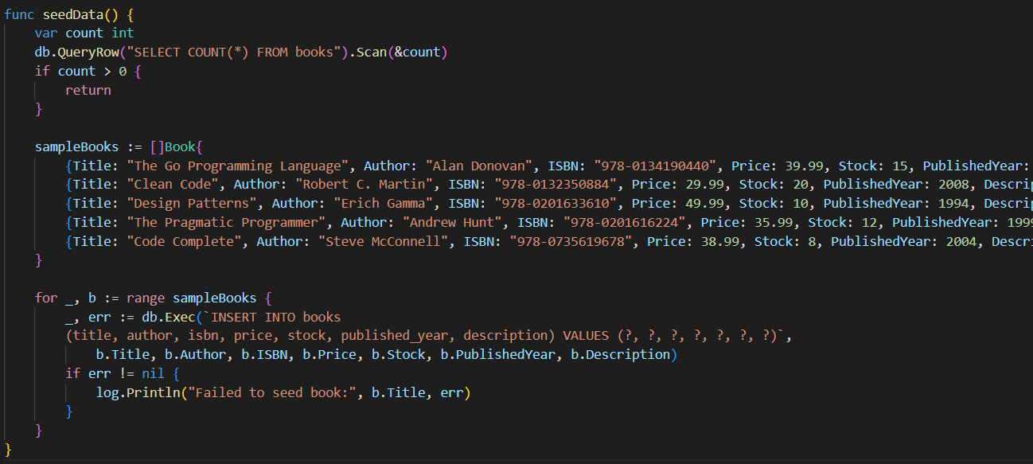
- Runs SELECT COUNT(*) FROM books and scans it into count.
- If count > 0, it returns early (no seeding).
- Otherwise, constructs a slice of Book values (sampleBooks) with classic programming book entries.
- Iterates the slice and inserts each book using db.Exec(...) with parameterized ? placeholders.
- Logs a message (via log.Println) if any individual insert fails (but continues seeding the rest).
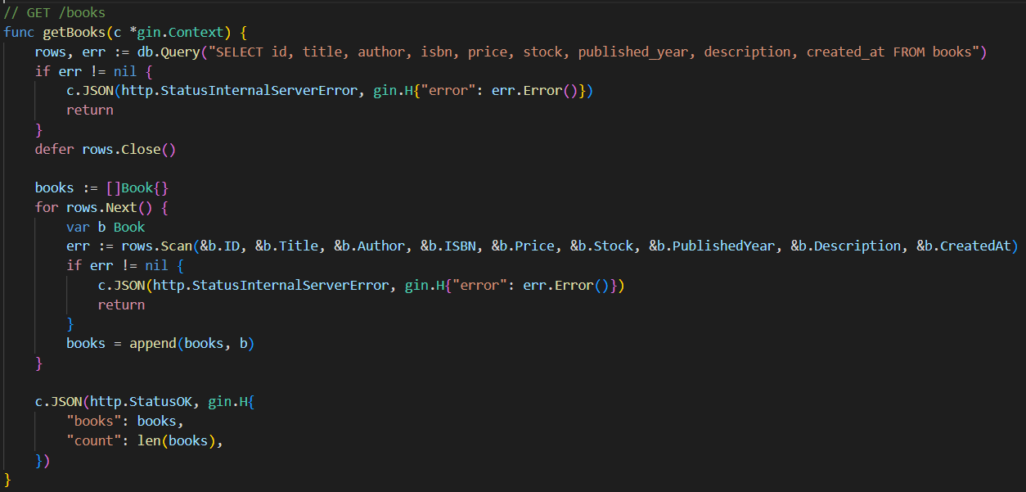
- Executes SELECT id, title, author, isbn, price, stock, published_year, description, created_at FROM books.
- Iterates rows.Next(), scanning each row into a Book struct and appending to books slice.
- If any DB error occurs during query or scan, responds with 500 Internal Server Error and the error message.
- If successful, responds with 200 OK and a JSON object
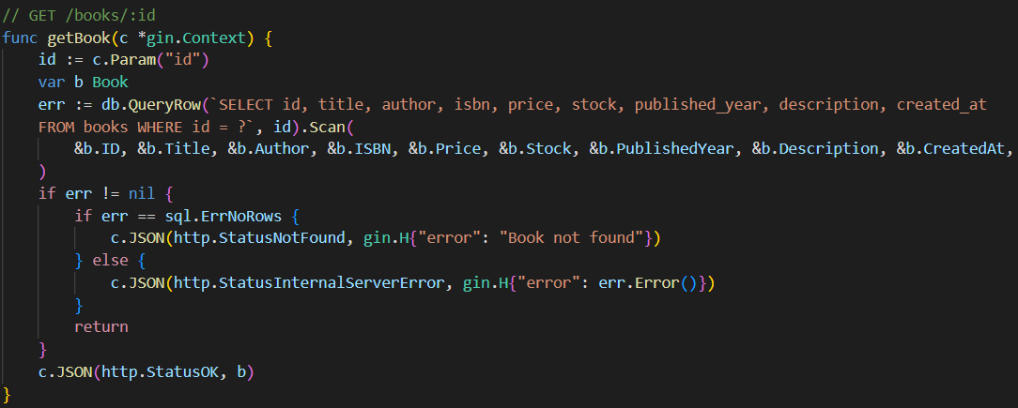
- Reads id from URL param: c.Param("id").
- Executes db.QueryRow(... WHERE id = ?).Scan(...) to fetch that book.
- If Scan returns sql.ErrNoRows, responds 404 Not Found with {"error": "Book not found"}.
- If another DB error occurs, responds 500 Internal Server Error with the error text.
- If successful, responds 200 OK with the Book JSON.
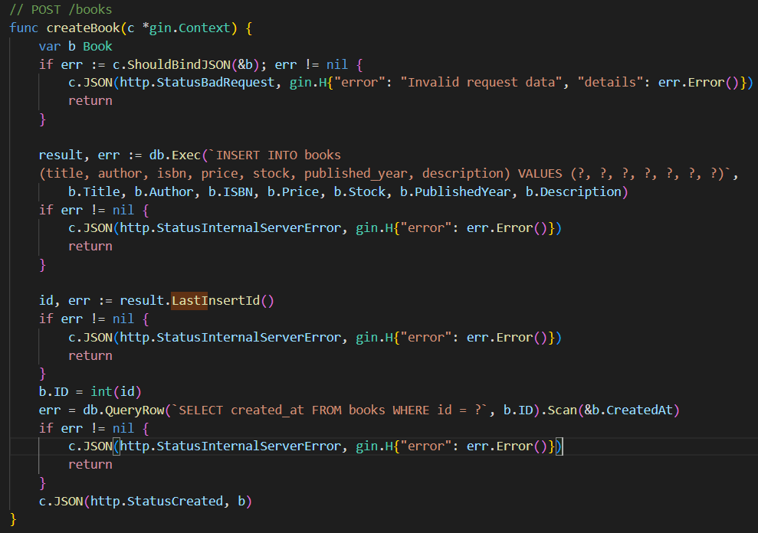
- Declares var b Book.
- Uses c.ShouldBindJSON(&b) — Gin binds the incoming JSON into b and enforces binding rules (e.g., title/author required, price > 0).
- If binding fails, responds 400 Bad Request with {"error":"Invalid request data","details":...}.
- Runs INSERT INTO books (...) VALUES (?, ?, ?, ?, ?, ?, ?) with parameters from b.
- If insert fails (e.g., unique ISBN constraint), responds 500 Internal Server Error with the error.
- Retrieves the last insert id via result.LastInsertId() and assigns it to b.ID.
- Sets err = db.QueryRow(`SELECT created_at FROM books WHERE id = ?`, b.ID).Scan(&b.CreatedAt) to reflect creation.
- Responds 201 Created with the created b JSON.
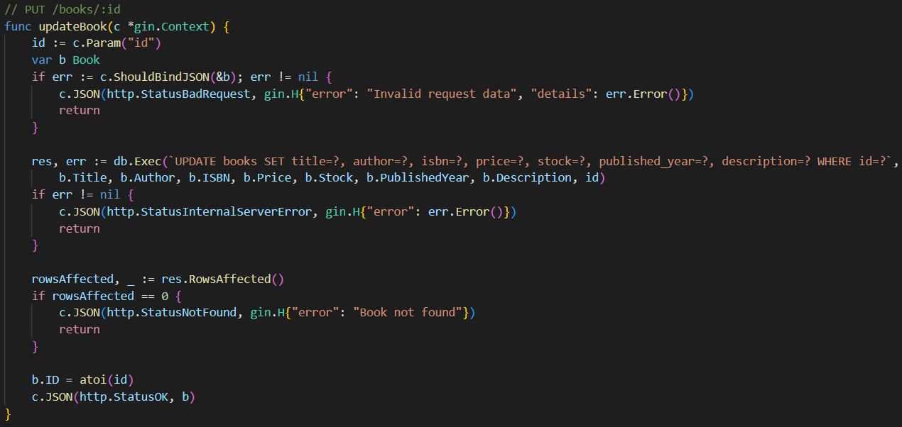
- Reads id from c.Param("id").
- Binds incoming JSON to var b Book using ShouldBindJSON. On bind error, responds 400 Bad Request.
- Executes an UPDATE books SET ... WHERE id = ? with values from b.
- Checks res.RowsAffected(); if 0 then no row matched → responds 404 Not Found.
- Sets b.ID = atoi(id) to reflect the updated record’s id (so the response object includes the id).
- Responds 200 OK with the b JSON.
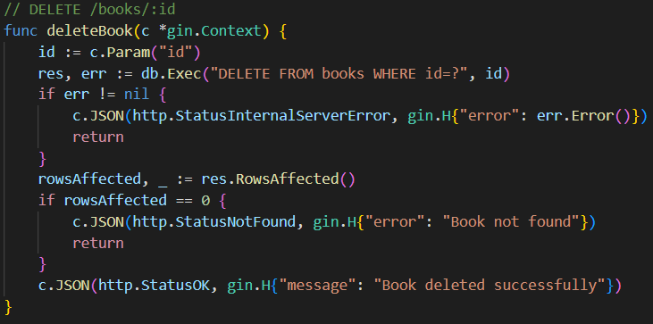
- Reads id from c.Param("id").
- Executes DELETE FROM books WHERE id = ?.
- Calls res.RowsAffected() to see how many rows were deleted.
- If 0, returns 404 Not Found ({"error":"Book not found"}).
- Otherwise returns 200 OK and {"message":"Book deleted successfully"}.
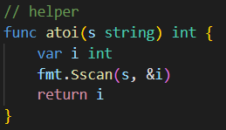
Declares var i int and uses fmt.Sscan(s, &i) to parse the string into i. Then, returns i. If parsing fails, i will be 0 (no explicit error handling).
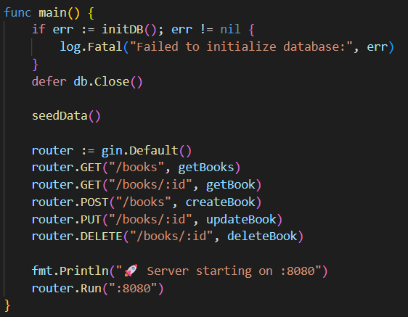
- Calls seedData() — inserts sample books if table empty.
- Registers routes and handler functions:
- GET /books → getBooks
- GET /books/:id → getBook
- POST /books → createBook
- PUT /books/:id → updateBook
- DELETE /books/:id → deleteBook
- Starts the HTTP server on port 8080 with router.Run(":8080").
Output:
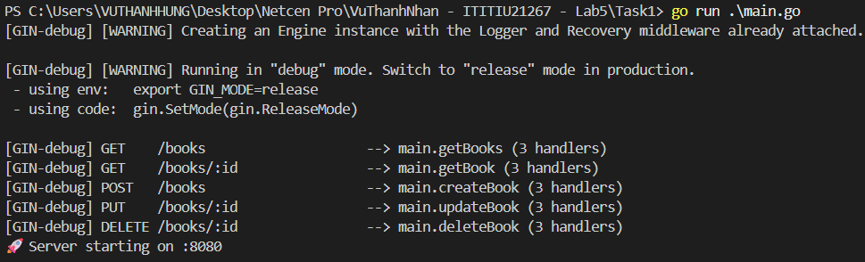
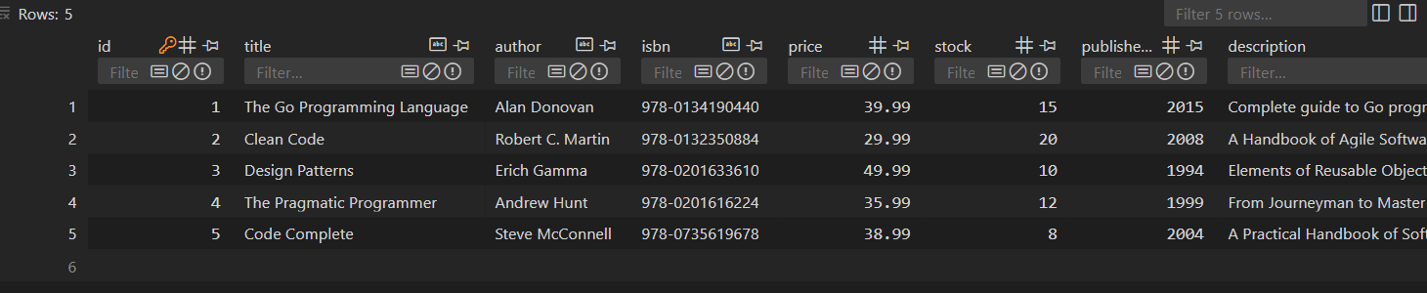
# Get all books
curl http://localhost:8080/books
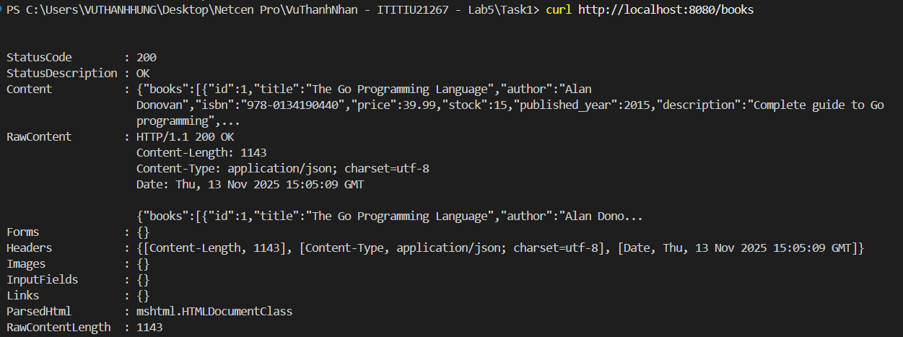
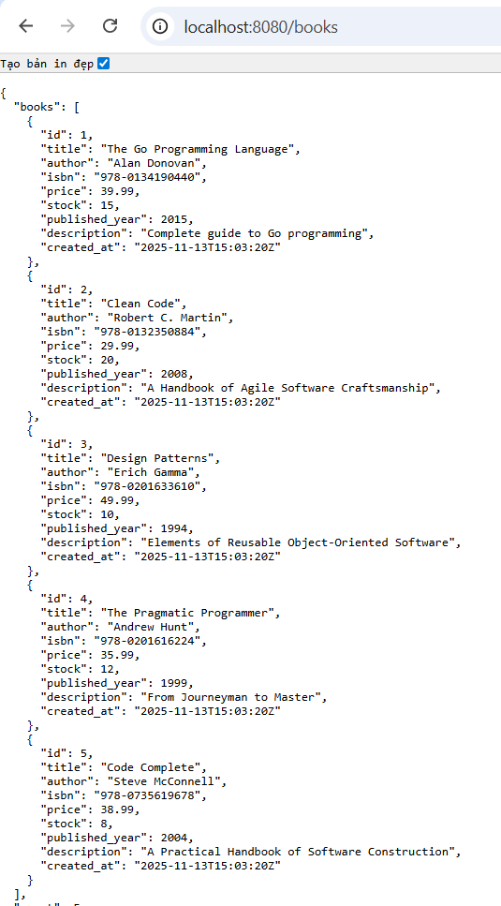
# Get book by ID curl http://localhost:8080/books/1
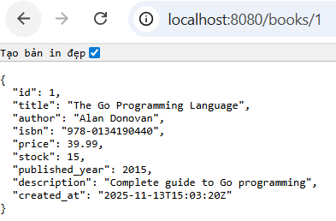
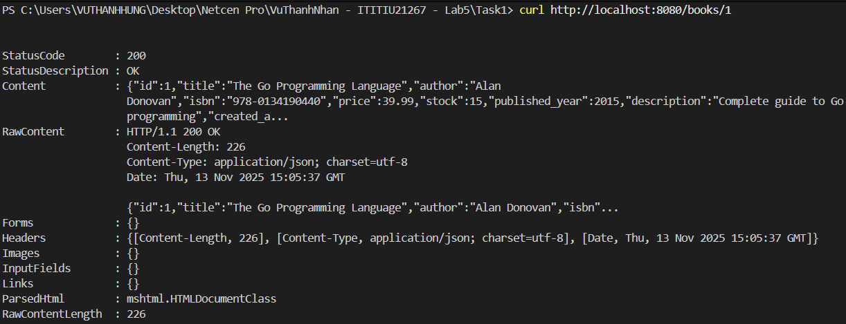
# Create new book
curl -X POST http://localhost:8080/books \ -H "Content-Type: application/json" \ -d '{ "title": "Learning Go", "author": "Jon Bodner", "isbn": "978-1492077213", "price": 44.99, "stock": 15, "published_year": 2021, "description": "An Idiomatic Approach to Real-World Go Programming" }'
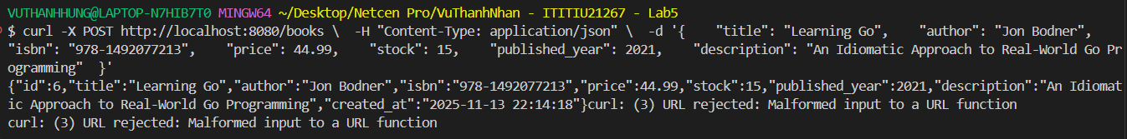
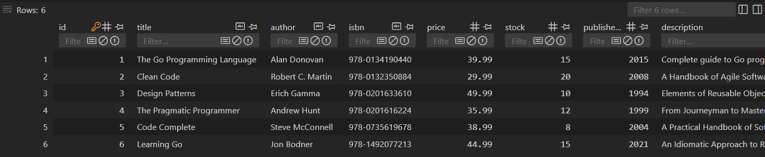

# Update book
curl -X PUT http://localhost:8080/books/1 \ -H "Content-Type: application/json" \ -d '{ "title": "The Go Programming Language (2nd Edition)", "author": "Alan Donovan", "isbn": "978-0134190440", "price": 39.99, "stock": 20, "published_year": 2015, "description": "Complete guide to Go programming" }'
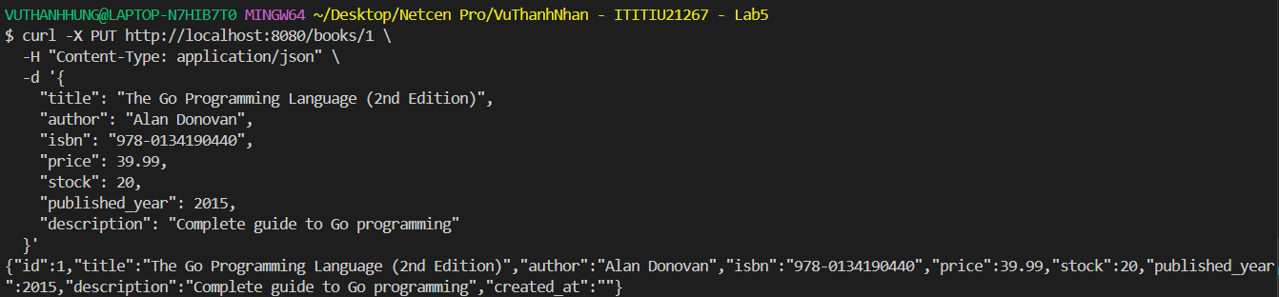

# Delete book
curl -X DELETE http://localhost:8080/books/1
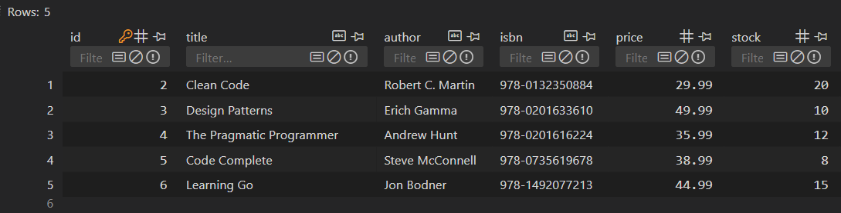

Task 2:
Only the following functions were modified from Task 1:
- getBooks(c *gin.Context)
- searchBooks(c *gin.Context)
- filterBooks(c *gin.Context)
All CRUD functions (getBook, createBook, updateBook, deleteBook) remain identical to Task 1.
Database initialization, seeding, and server setup (main()) are unchanged.
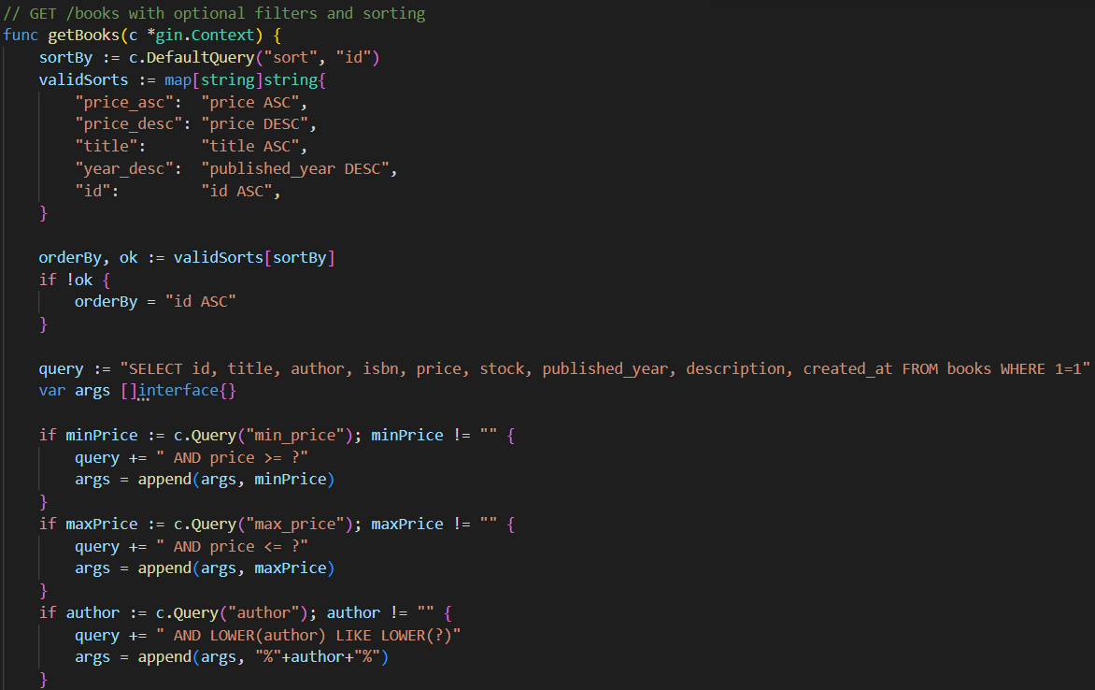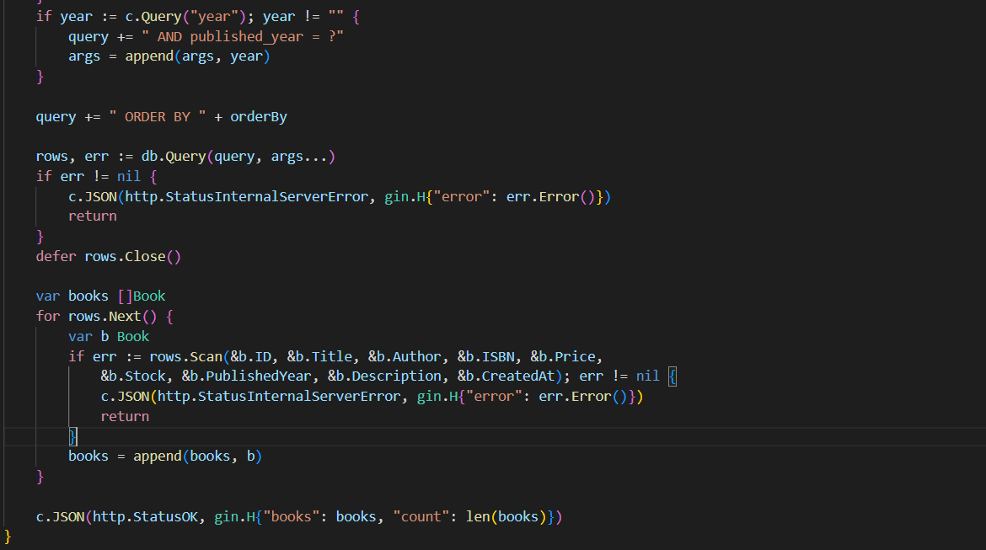
- Reads sort query param; defaults to "id".
- Maps allowed sort values to SQL ORDER BY clauses.
- Builds a base SQL query: SELECT ... FROM books WHERE 1=1.
- Checks optional query parameters and adds them to SQL:
- min_price → AND price >= ?
- max_price → AND price <= ?
- author → AND LOWER(author) LIKE LOWER(?)
- year → AND published_year = ?
- Appends ORDER BY clause.
- Executes query and scans rows into Book structs.
- Returns JSON with books and count.
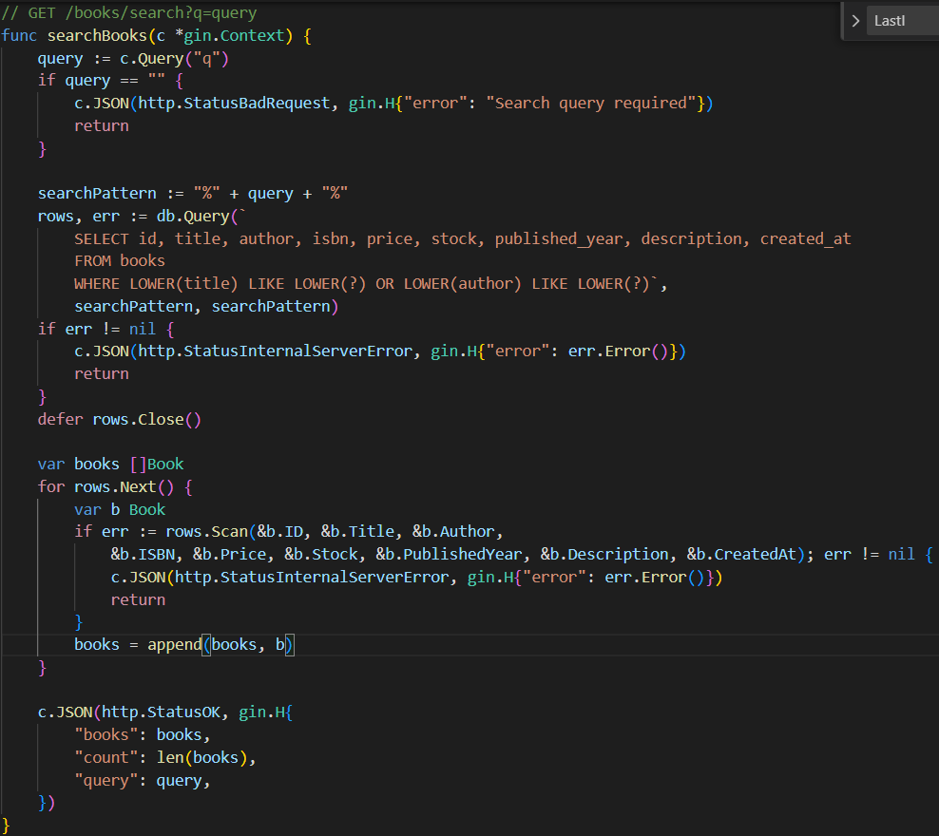
- Reads q from query parameter.
- Returns 400 if q is empty.
- Prepares search pattern: %query%.
- Executes SQL: WHERE LOWER(title) LIKE LOWER(?) OR LOWER(author) LIKE LOWER(?).
- Iterates over rows and scans them into Book structs.
- Returns JSON with books, count, and the original query.
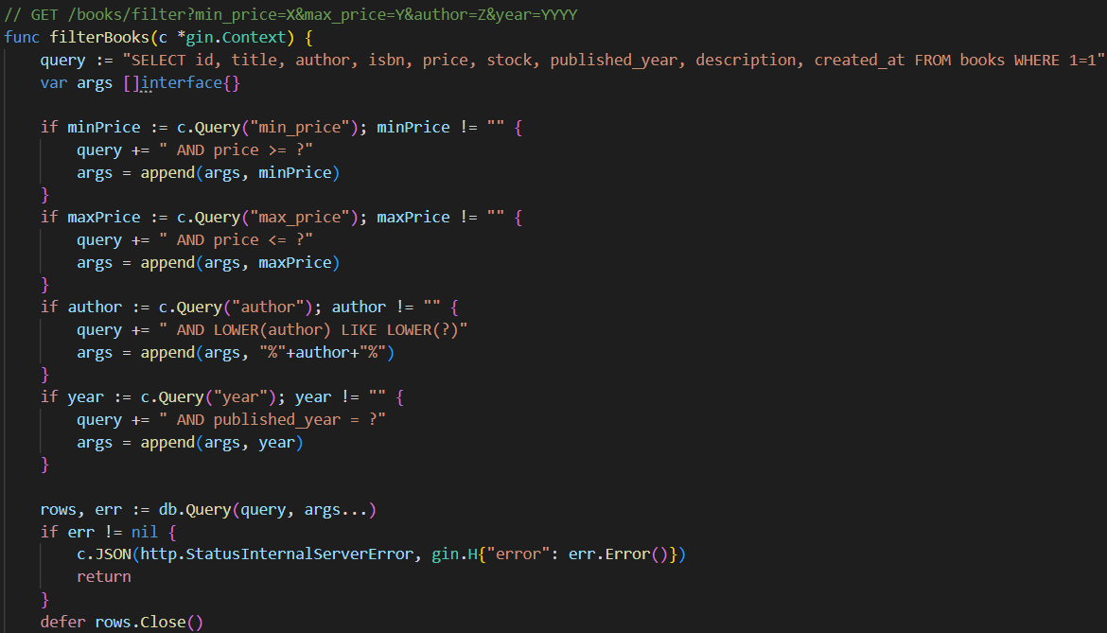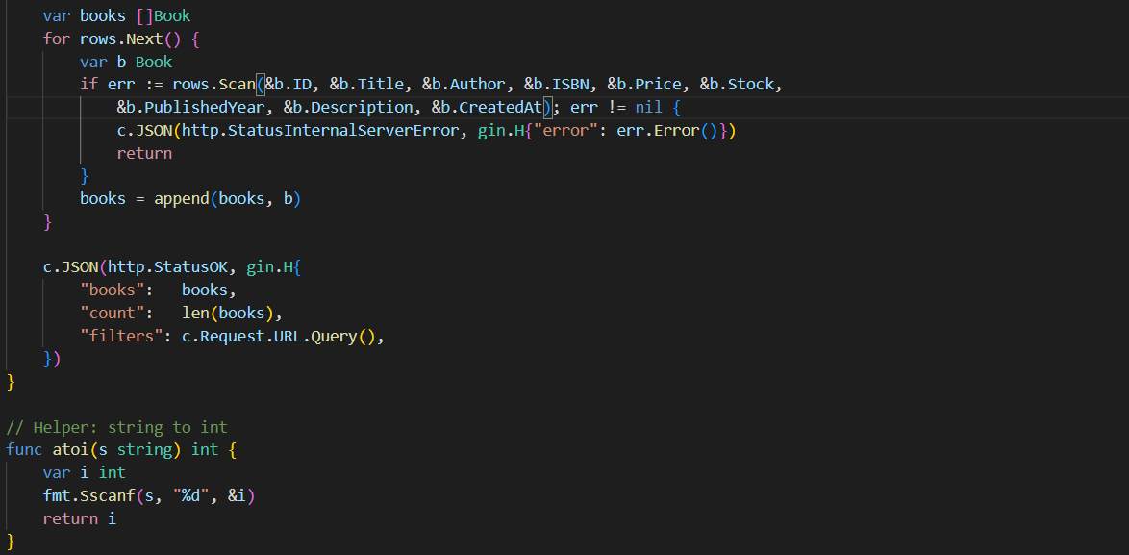
- Builds base query: SELECT ... FROM books WHERE 1=1.
- Reads query params and appends SQL conditions if present:
- min_price → AND price >= ?
- max_price → AND price <= ?
- author → AND LOWER(author) LIKE LOWER(?)
- year → AND published_year = ?
- Executes query with the collected arguments.
- Scans results into Book structs.
- Returns JSON with books, count, and filters applied.
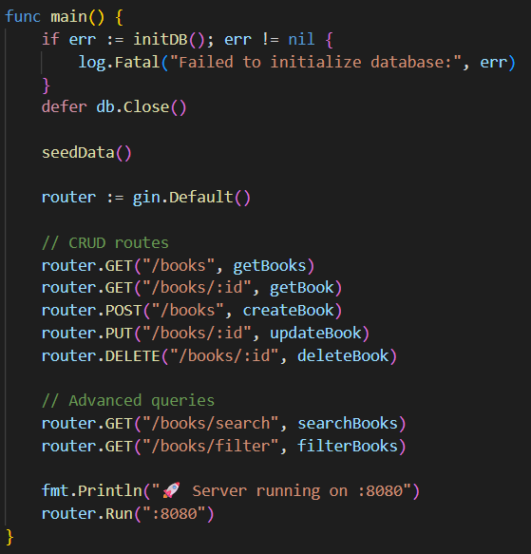
- Calls seedData() — inserts sample books if table is empty.
- Creates a Gin router with router := gin.Default().
- Registers CRUD routes:
  - GET /books → getBooks
  - GET /books/:id → getBook
  - POST /books → createBook
  - PUT /books/:id → updateBook
  - DELETE /books/:id → deleteBook
- Registers Advanced Query routes:
  - GET /books/search → searchBooks
  - GET /books/filter → filterBooks
- Starts the HTTP server on port 8080 via router.Run(":8080").

Output:
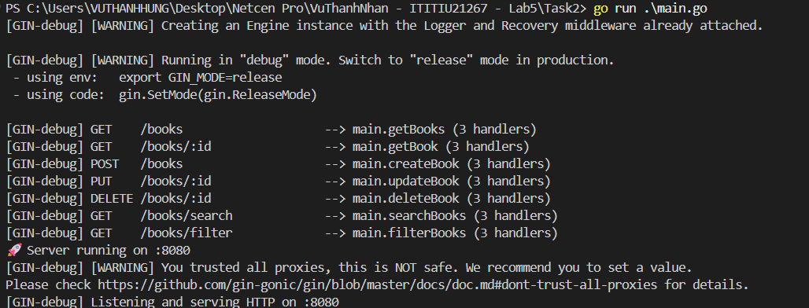
# Search books
curl "http://localhost:8080/books/search?q=go"
curl "http://localhost:8080/books/search?q=programming"
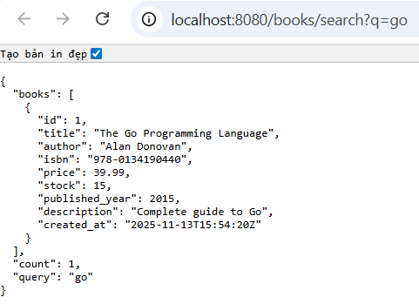
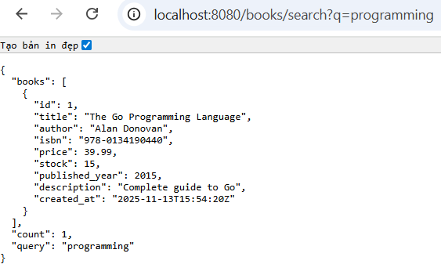
# Filter by price range
curl "http://localhost:8080/books/filter?min_price=20&max_price=45"
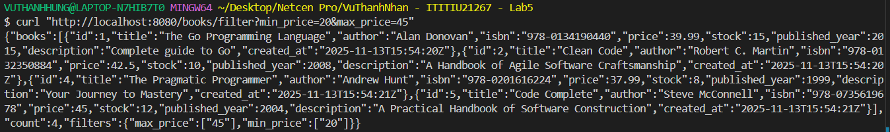
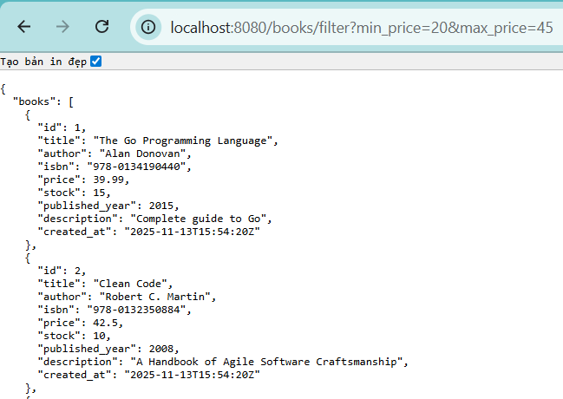

# Filter by year
curl "http://localhost:8080/books/filter?year=2021"
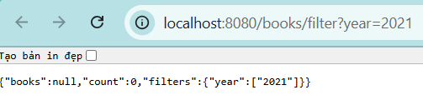
# Filter by author
curl "http://localhost:8080/books/filter?author=Martin"
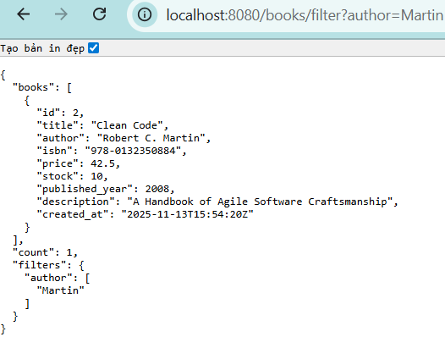
# Combine filters
curl "http://localhost:8080/books/filter?min_price=30&author=Don"
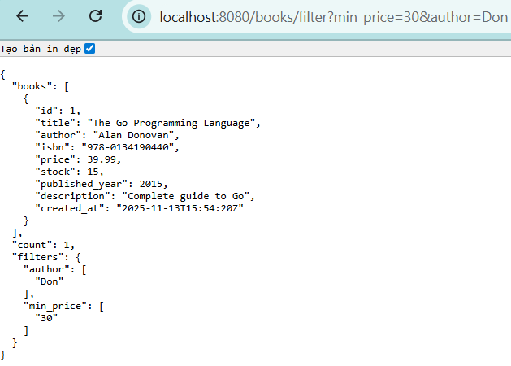
# Sort books
curl "http://localhost:8080/books?sort=price_asc"
curl "http://localhost:8080/books?sort=title"
curl "http://localhost:8080/books?sort=year_desc"
